**Experiment No. 2**

Area of Rectangle , Triangle and Circle :

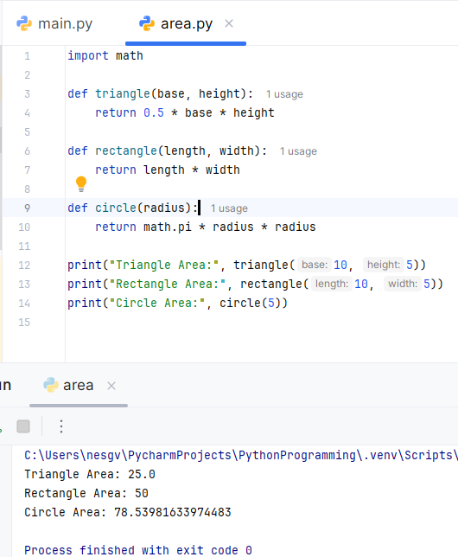

**OUTPUT :**

**Experiment No. 3**

Union of Two Lists a and b :

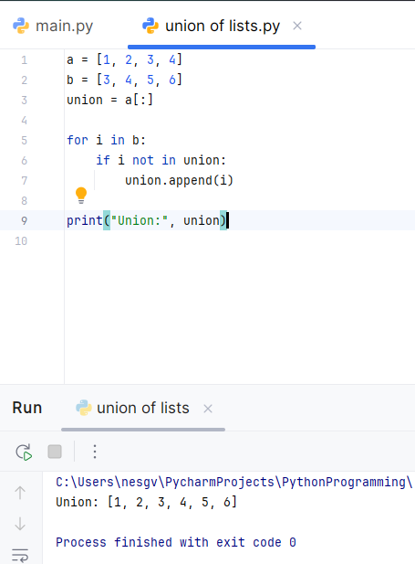

**OUTPUT :**

**Experiment No. 4**

Intersection of Two Lists a and b :

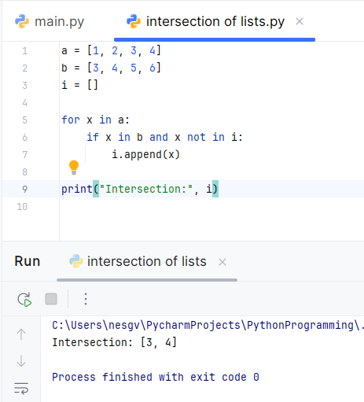

**OUTPUT :**

**Experiment No. 5**

Program 1: Remove All Occurrences of a Number from a List

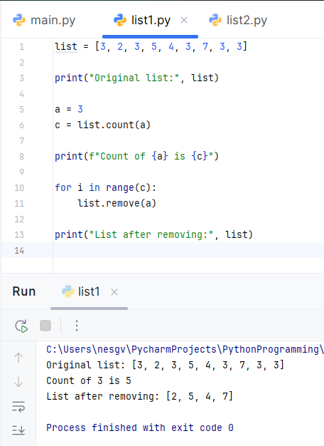

**OUTPUT :**

Program 2: Remove All Occurrences of a Word from a List

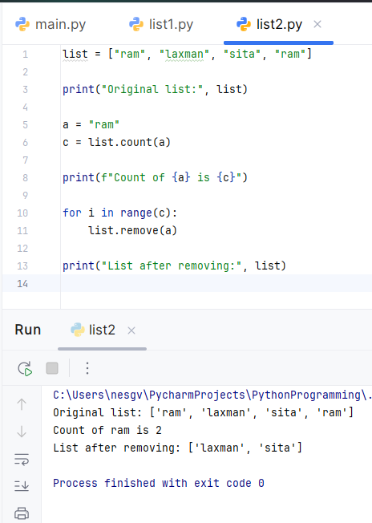

**OUTPUT :**

**Experiment No. 6**

Program to Count the Occurrence of a Word in a User-Entered Sentence

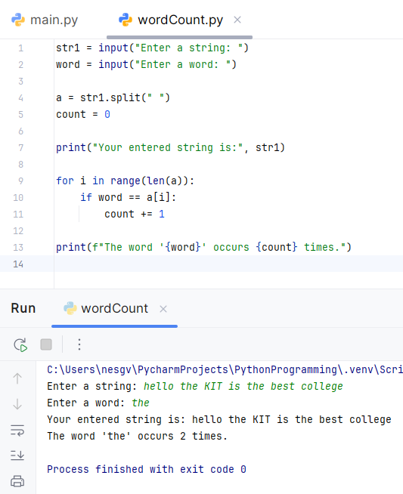

**OUTPUT :**